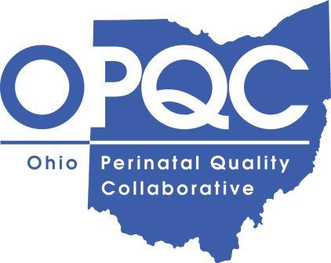

To Whom It May Concern,
As the authorized representative of the Ohio Perinatal Quality Collaborative and owner of the content in question (“insert name of document here”), we give permission to insert name of organization here and any representatives of the said organization to print and distribute the guide as they wish.
We attest that “insert name of document here” is under a “Creative Commons Attribution Non-Commercial License.” Thus, insert name of organization here and representatives of the said organization are free to share (copy and redistribute the material in any medium or format) and adapt (remix, transform, and build upon the material) the content in question.
If you have any questions or concerns, please do not hesitate to contact us directly.

Respectfully,
OPQC Central
info@opqc.net

